RESOLUTION NO.__________

RE: CERTIFICATE OF APPROPRIATENESS UNDER THE
PROVISIONS OF THE ACT OF THE PENNSYLVANIA
LEGISLATURE 1961, JUNE 13, P.L. 282 (53
SECTION 8004) AND BETHLEHEM ORDINANCE NO.
3952 AS AMENDED.

WHEREAS, it is proposed to install an additional sign at 325 Broadway.

NOW, THEREFORE, BE IT RESOLVED by the Council of the City of Bethlehem that a Certificate of Appropriateness is hereby granted for the work.

Sponsored by: (s)

(s)

ADOPTED BY COUNCIL THIS DAY OF

(s)
President of Council

ATTEST:

(s)

City Clerk

HISTORIC CONSERVATION COMMISSION

CASE # 394 – It is proposed to install an additional sign at 325 Broadway.
OWNER/APPLICANT: Sycamore Hill Farm Development / John Park

The Commission upon motion by Mr. Roeder and seconded by Mr. Evans adopted the proposal that City Council issue a Certificate of Appropriateness for the proposed work described herein:

- The proposal to install an additional sign at 325 Broadway was presented by John Park.

- The proposed sign will be 85” x 17” and read “Metro PCS” on a dark blue background with “metro” in white lettering and “PCS” in orange lettering.

- “Authorized Dealer” must be removed from below the existing sign and added to the new sign in red or orange lettering.

- The sign is to be vinyl, fully adhered to the transom window.

- A scaled drawing of sign must be submitted for review by the Historic Officer.

- The proposed work was unanimously approved.

CU: cu

By: 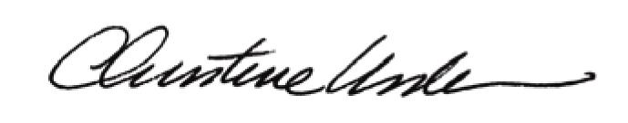

Date of Meeting: November 21, 2011 Title: Historic Officer

